Title Page
(A typical Specimen of Cover Page & Title Page)
TITLE OF PROJECT
Capstone Project Proposal
Submitted by:
(<University Roll Number>)NAME OF THE STUDENT(s)

BE Third Year- COE/ CSE
CPG No. _____

Under the Mentorship of
Name of Faculty Mentor
Designation
Name of Co-Mentor (if any)
Designation


Computer Science and Engineering Department
Thapar Institute of Engineering and Technology, Patiala
MONTH & YEAR
TABLE OF CONTENTS

- Mentor Consent Form <Page No>
- Project Overview <Page No>
- Problem Statement …..
- Need Analysis (1 Page) …..
- Literature Survey (3 Pages) …..
- Objectives
- Methodology
- Project Outcomes & Individual Roles
- Work Plan
- Course Subjects
- References

Mentor Consent Form
I hereby agree to be the mentor of the following Capstone Project Team
Project Title:
Roll No | Name | Signatures

NAME of Mentor: ……… . . . . . . . . . . . . . . . . . . . . . . . . . . . . . . . . . . .
SIGNATURE of Mentor: . . . . . . . . . . . . . . . . . . . . . . . . . . . . . . . . . . . .

NAME of Co-Mentor(if any): ……… . . . . . . . . . . . . . . . . . . . . . . . . . .
SIGNATURE of Co-Mentor: . . . . . . . . . . . . . . . . . . . . . . . . . . . . . . . . . . . .

Project Overview
- Complete overview of the capstone project.
- (Max one page-three paragraphs)

Need Analysis
- You need to present a short description (One page) of why there is a need for the proposed project and its relevance in the real world.
- You may cite some other existing systems/base research papers (details to be mentioned in Literature survey) (Optional)

Literature Survey
- You need to carry out a detailed survey in your respective field (3 pages).
- Present that literature survey of the systems/products/projects already existing in the real world in this section.

Objectives
- You need to list the objectives (3-4) that you wish to achieve at the end of the capstone project.
- At the end of the final evaluation of the capstone project, these objectives will be used to judge your project completion status.

Methodology
- You need to discuss the stepwise methodology of achieving the set objectives in this section. (Diagram along with stepwise description is a good tool to explain the methodology)

Work Plan
- You need to give a short work plan which you will set for achieving the set objectives, in this section.
- Sample:-
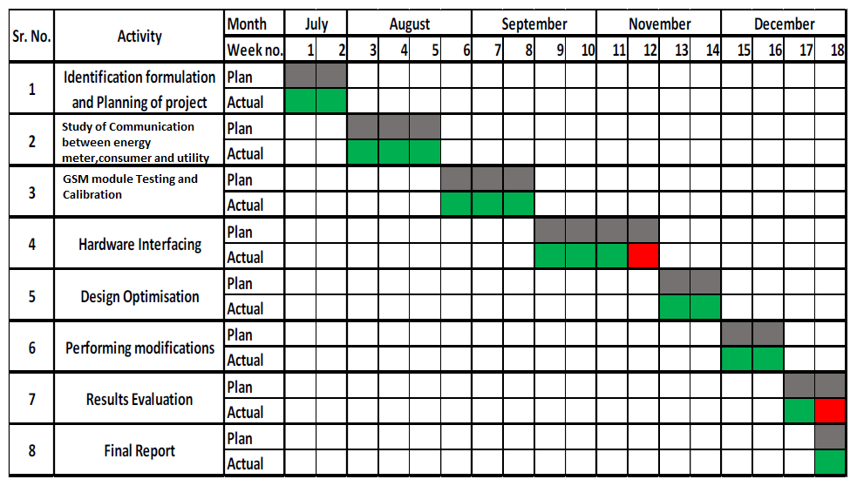

Project Outcomes & Individual Roles
- Here, you need to list the final outcomes/ products/ systems/ deliverables of your capstone project.
- The individual team member role must also be clearly specified in this section.

Course Subjects
- In this section, you need to list the course subjects that will be used (in the form of conceptual knowledge or practical skills sets) during the successful execution of your capstone project.

References
Formatting Guidelines
- Project Report Type: Transparencies and tape bound
- Number of Copies: 1 per Project group (Max pages 15)
- Running text should be justified, figures and tables center aligned, no space before full stop etc.
- Use passive voice in text.
- Paper Size (orientation): A4 (portrait)
- Margins: 1” top / bottom / right and 1.5” left
- Font Type: Times New Roman
- Font Size: 16 bold for Section names, 14 bold for headings and 12 for normal text
- Line Spacing: 1.5 throughout
- Page Numbering: Bottom center of page in the format – Page 1 of N
- All table and figure captions in size 10 sentence case, table captions on top and figure captions below the figure.
- All figures and tables quoted in the text with explanation.
- No figures and equations should be copied. Please use smartdraw/ visio for figures/FIGMA and Mathtype for equations.
- References (The listing of references should be typed 2 spaces below the heading “REFERENCES” in alphabetical order in single spacing left – justified. It should be numbered consecutively (in square [ ] brackets, throughout the text and should be collected together in the reference list at the end of the report. The references should be numbered in the order they are used in the text. The name of the author/authors should be immediately followed by the year and other details). References should not be cited from Blogs, Twitter etc. but should refer to good Journal or Conference papers. Typical examples of the references are given below:

